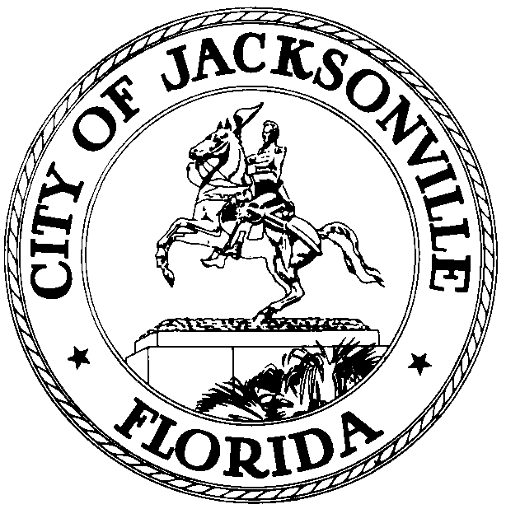

OFFICE OF THE CITY COUNCIL

Jacksonville Waterways Commission
117 W. Duval Street, Suite 425, Jacksonville, Florida 32202

August 2, 2021
5:00 PM

M E M O R A N D U M

TO: Jacksonville Waterways Commission’s
Artificial Reefs of Northeast Florida Committee

Raymond S. Pringle Jr.
Mark Devereaux
Marshall Adkison

FROM: Lindsey Brock, Chair

RE: Artificial Reefs of Northeast Florida Committee Meeting

As Chair of the Artificial Reefs of Northeast Florida Committee, I am hereby scheduling a meeting for Friday, August 6, 2021 at 2:00 p.m., in the Lynwood Roberts Room, City Hall, 117 West Duval Street, 1st Floor, Jacksonville, FL 32202. The purpose of this meeting is to discuss the potential and existing Artificial Reefs of Northeast Florida. All parties are welcome to attend.

Please mark your calendars accordingly.

LB/ms

E-mail: Council Members/Staff
Cheryl Brown, Director/Council Secretary
Jessica Matthews, Chief, Legislative Services
Margaret M. Sidman, Deputy, General Council
Paige Johnston, Chief, General Counsel
Jeff Clements, Chief of Research
Susan Grandin, Asst. General Counsel
CITYC@COJ.NET
Posted Notice Board, 1st Fl, City Hall
Public Notice System, City Council Web Page
Media Box

